#10. Appendix - Scalar Fields

#10.1 Methods of Creating Scalar Fields

A basis function is an element of a particular basis for a function space.
To approximate any scalar field, a linear superposition of basis functions can be used. The functions chosen for the approximation can also be chosen from different types of bases (eg: combining polynomials and sinusoids). However, not all functions can be approximated with a finite linear combination. For instance, approximating a square function may require an infinite sum of sinusoidal functions to be approximated well. Some of these bases are discussed below:
- Constant Fields
A constant field takes on the form in equation 3. Constant fields apply a constant value across the entire field. However, by restricting the domain of the constant field to a subdomain of a single point, then a unique constant can be assigned at each point in the larger domain. By knowing the z value for every location on the x,y plane, any field can be approximated using this technique. The result is a digital version of the analogue continuous field (see Fig 5).
$$\begin{aligned}F(x,y)=c\#\left(3\right)\end{aligned}$$

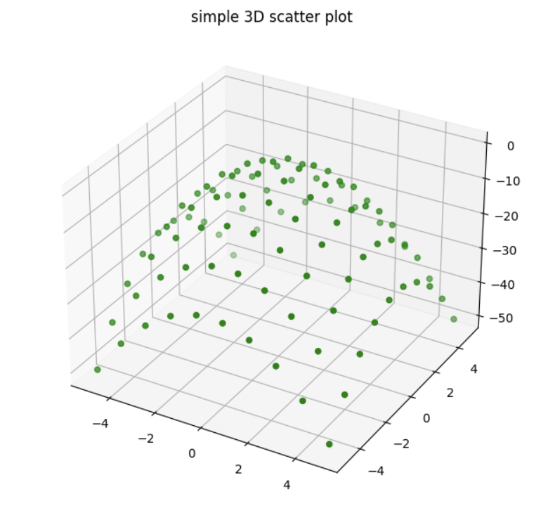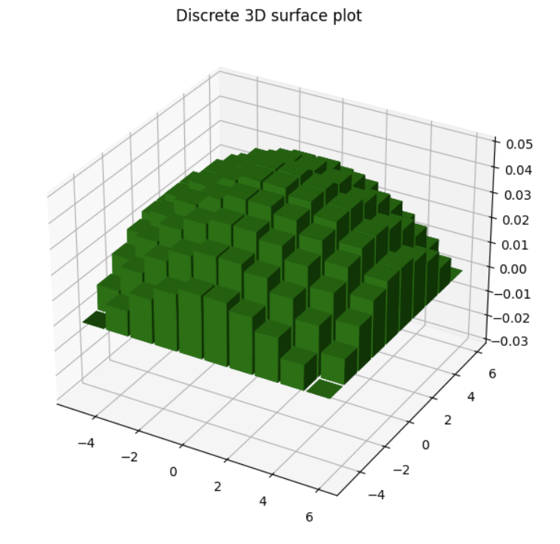
Figure 5. A Digitized version of a Hill.
- Linear Fields
Linear fields, like constant fields, are an intuitive basis for creating fields, and be programmed with relative ease. They take the form of the equation of equation 4.
$$\begin{aligned}F\left(x,y\right)=ax+by+c\#\left(4\right)\end{aligned}$$
- Radial Fields and Inverse Radial
Fields that decrease proportionally to 1/r or increase proportionally to r. These are intuitive and can be combined easily with other basis functions.
$$\begin{aligned}F\left(x,y\right)=\frac{a}{\sqrt{x^{2}+y^{2}}}\#\left(5\right)\end{aligned}$$
$$\begin{aligned}F\left(x,y\right)=a\sqrt{x^{2}+y^{2}}\#\left(6\right)\end{aligned}$$

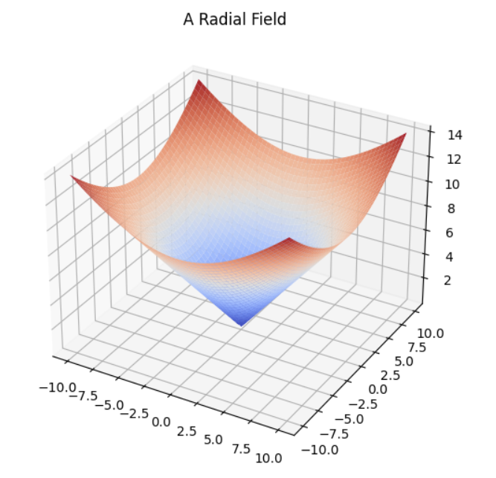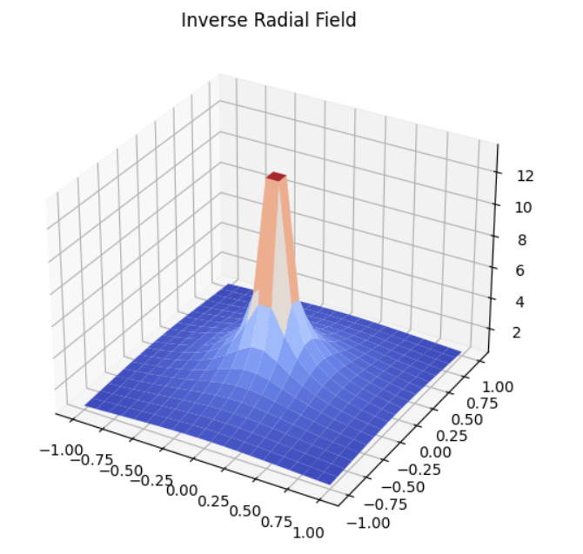
Figure 6. Radial Fields as well as an inverse radial field.
- Circular Fields
This equation represents a corkscrew pattern. This function contains a discontinuity on the x axis, which can be useful under modelling some circumstance (such as the cliffs discussed in section 4.2)
$$\begin{aligned}F\left(x,y\right)=a*arctan2(y,x)\#\left(7\right)\end{aligned}$$
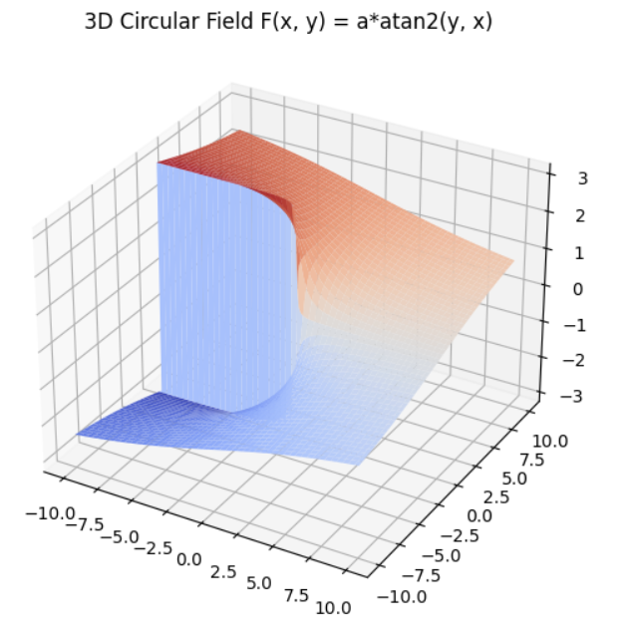
Figure 7. Circular Fields, notice the cliff

- Gaussian Fields
$$\begin{aligned}F\left(x,y\right)=a^{\frac{x^{2}+y^{2}}{2σ^{2}}}\#\left(8\right)\end{aligned}$$

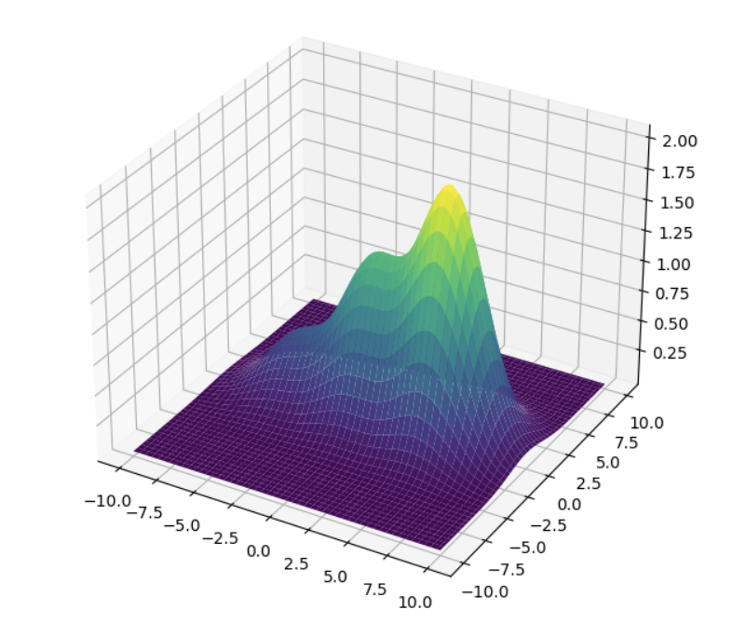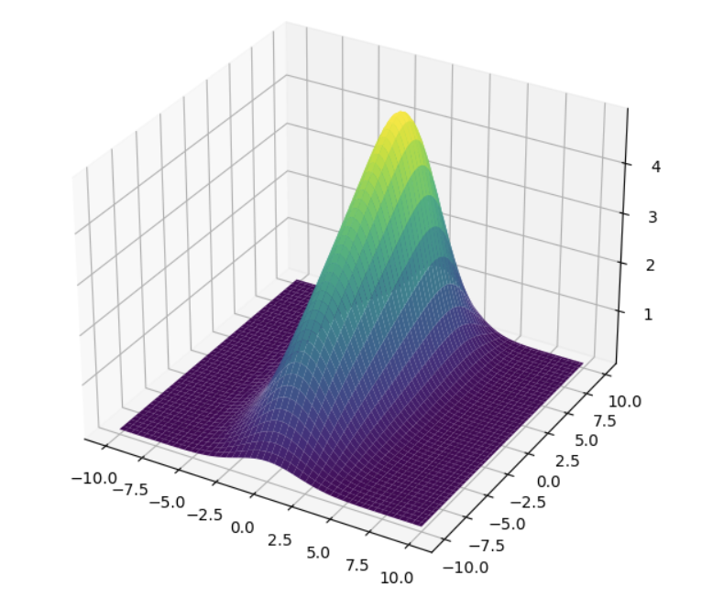
Figure 8. Gaussian Fields

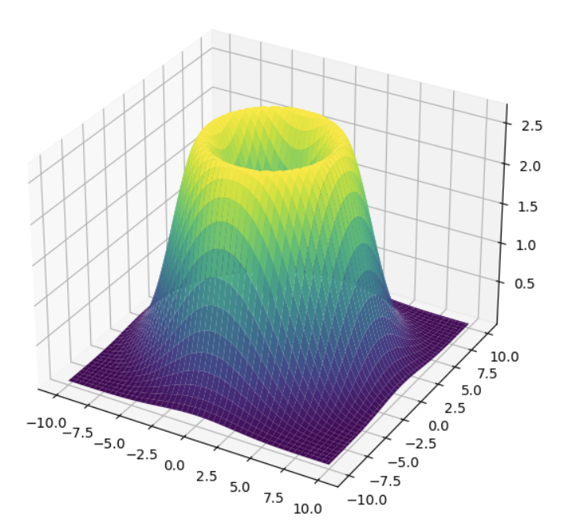
Figure 9. Volcanic Ring made of Gaussians

- Sinusoidal Fields
Sinusoidal bases excel at approximating fields with periodic behavior. However, their effectiveness diminishes when approximating non-periodic fields.
$$\begin{aligned}F\left(x,y\right)=a*sin(k*x) + b*sin(m*y)\#\left(9\right)\end{aligned}$$

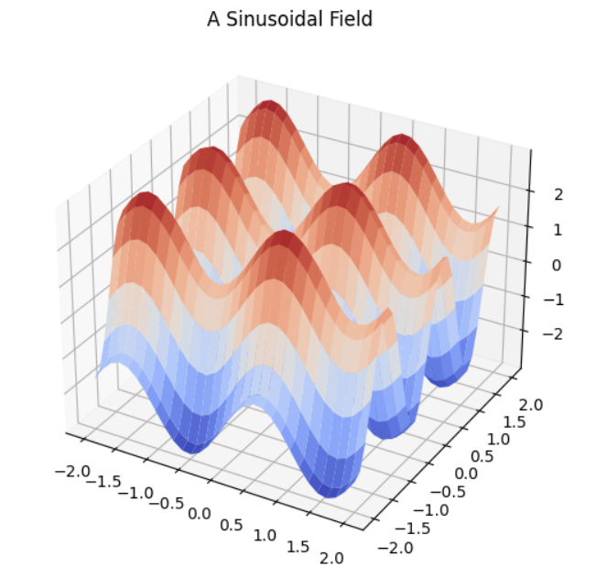
Figure 10. A Sinusoidal Field

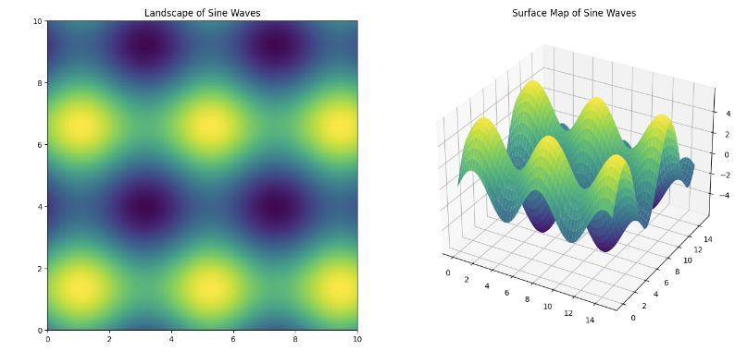
Figure 11. A field of sines waves and corresponding topographic map

- Polynomial Fields
Various types of polynomials were considered, including Chebyshev polynomials, Laguerre Polynomials, Legendre polynomials. Since all the special types (Chebyshev, etc.) are still a subset of polynomials, the overall set of polynomials in the form below provide the most flexibility in use.
$$\begin{aligned}F\left(x,y\right)=ax+{bx}^{2}+cx^{3}+…+dx^{n}+fy+gy^{2}+…+zy^{m} \#\left(10\right)\end{aligned}$$
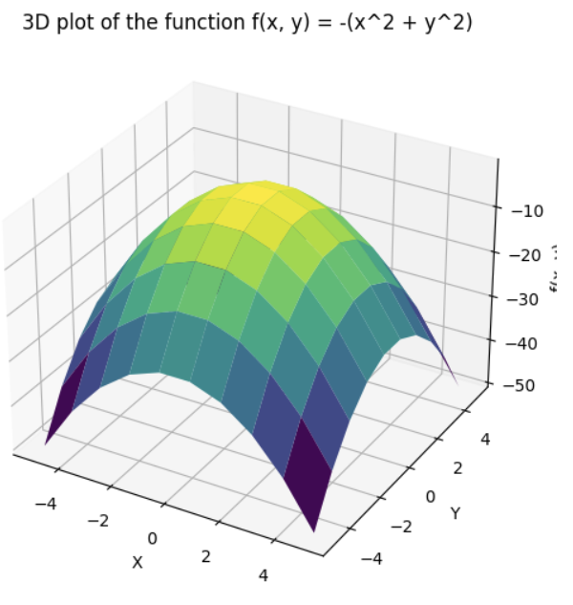
Figure 12. A Polynomial Curve of Order 2
- Bessel Functions
While the shape of Bessel Functions is quite promising visually, the mathematics and computation involved are quite complex to implement. As a result, they are not well suited to my current research.
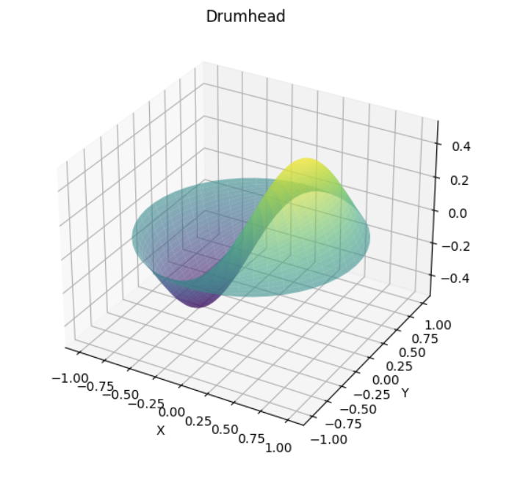
Figure 13. A Bessel Function

Other Exotic Basis
Wavelets, Radial Basis Functions, and Spherical Harmonics were also considered. Spherical harmonics, like sinusoidal bases, are particularly effective when modeling environments that exhibit periodic behavior. However, the mathematical complexities and computational requirements associated with these other bases made them less suitable for my current research.

Section 4.2 shows some examples of complex fields that were generated using linear combinations of these basis.

#4.2 Scalar Field Regions of Interest

By creating combinations of the basis above, and with a little research into topology and topography, the following regions of interest were identified:

 | Feature | Studied? | Reference
1 | Global Maximum
2 | Local Maximum
3 | Global Minimum
4 | Local Minimum
5 | Ridge to Mountain Peak
6 | Coulier (channel to Mountain Peak)
7 | Summit Ridge | ?
8 | Volcanic Rim | ?
9 | Trench | ?
10 | Trench Ring | ?
11 | Saddle Point
12 | Monkey Saddle
13 | False Summit
14 | Cliffs
15 | Sloped Planes
16 | Mesas
17 | Voids
18 | Tunnels – No Longer have a hypershere
Table 1: List of Scalar Field Features of Interest

#4.3 Methods of Navigating Towards Features of interest

 | Feature | Navigation Technique
1 | Global Maximum
2 | Local Maximum
3 | Global Minimum
4 | Local Minimum
5 | Ridge to Mountain Peak
6 | Coulier (channel to Mountain Peak)
7 | Summit Ridge
8 | Volcanic Rim
9 | Trench
10 | Trench Ring
11 | Saddle Point
12 | Monkey Saddle
13 | False Summit
14 | Cliffs / Fronts
15 | Sloped Planes
16 | Mesas
17 | Voids
18 | Tunnels – No Longer have a hypersphere
Table 2: List of Navigation Techniques to find Features of Interest

